Lesson 7 Handout: Cyclone Structure & Convection

Section A: Cyclone Structure Diagram
Label the diagram of the cyclone with the following terms: Eye, Eye Wall, Rain Bands, Spiral Arms, Warm Air Rising, Cool Air Sinking.

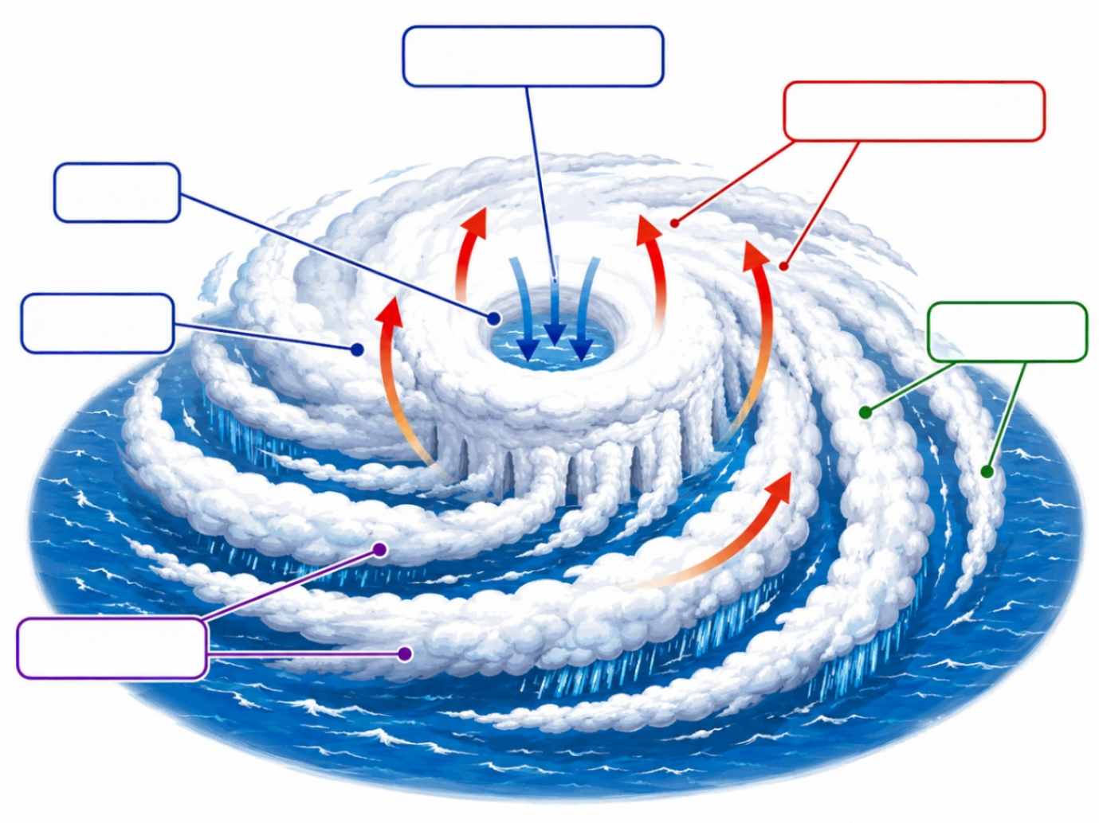
Section B: Annotations
Choose 4 labels from above and add an annotation (explanation) for each:
1. ________________: ___________________________________________
2. ________________: ___________________________________________
3. ________________: ___________________________________________
4. ________________: ___________________________________________

Section C: Reading Comprehension
1. Why did many homes fail during Cyclone Althea?
____________________________________________________________
2. What is the role of the Cyclone Testing Station?
____________________________________________________________
____________________________________________________________

